CV of teachers
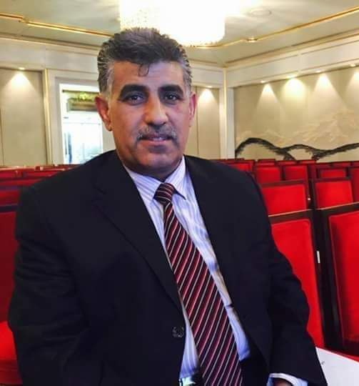
Full Name: Nabil wadai Hammoud
The scientific title: teacher
Certificate: Ph.D
General jurisdiction: Cinematic and Television Arts
Exact jurisdiction: Cinema
Years of service: 27
Date of Birth:
the address:DIAYLA BAQUBA
E-mail:nabeelwadaii@gmail.com
Phone number (optional):07718163356

Admi Course of the Department of Cinematic and Television Arts
Secretary of the Council of the College of Fine Arts
Responsible for the Missions and Cultural Relations Divisionnistrative assigned positions

Academic experiences (research evaluation, journals, etc.)
- Jury at the Film Festival Against Terrorism
Member of the Writers Union
Secretary of Baquba Chess Club
Social cultural content creator

Experience (exhibition work, conferences, research contract, everything related to the specialization outside the teaching process)
Documentary films about historical and heritage areas, personalities, artistic, literary and social
Research (Teaching Research)
-mention it

Courses and Conferences
-mention it

Artistical works
-mention it

Committees
-mention it

Subjects for the initial study (the subjects taught by the teacher)
- Drama principles
principles of photography
Cinema output
Narrative science
Directing the documentary
Montage aesthetics
Output applications
cinematic composition
Postgraduate study subjects (the subjects taught by the instructor)
-mention it

Supervision and discussion of research (postgraduate studies only)
-mention it

Authored books
1 book

Awards won
-mention it

skills
Filming, Editing, Screenwriting / Voiceover /
Thanks Books
10

Languages
Arabic

